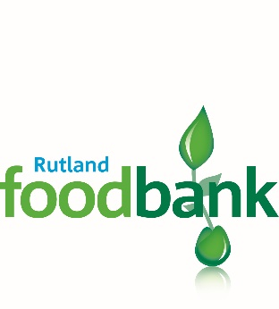
Charity No 1158460
Dear Rutland Foodbank Supporter,
Rutland Foodbank opened its doors in September 2013. It is a privilege to meet the needs of some of the poorest individuals and families in Rutland. It costs on average about £7000 each year to run the Foodbank. We have received generous gifts of food and financial support since opening but know that a regular income would help us budget for future needs and also enable us to offer more services in the community.

If you would like to make a regular standing order to support the ongoing work of Rutland Foodbank, please complete the form at the bottom of this letter and return it to your bank.

If you are an income tax or capital gains tax payer and would like the charity to claim gift aid on your donation, please complete the Gift Aid Declaration attached and return to the Treasurer at the address at the bottom.

Thank-you for your support,

Rutland Foodbank Trustees

Rutland Foodbank Monthly Standing Order

To the ________________________________________ Bank/Building Society
Address: __________________________________________________________
__________________________________________________________________ __________________________________________________________________

Please debit my/our Account Number: ___________ Sort Code: _____________ and transfer to CAF Bank Ltd, Sort Code 40 – 52 – 40 for the account of Rutland Foodbank Account Number 00034016,
from _______ (insert start date) and subsequently on the first of each month, or the next working day thereafter, the sum of £________ (insert amount of donation) until I/we instruct otherwise.
Please quote my/our account name as the reference.

Signature(s) _________________________________________________

Date _________________________
(When completed, please pass this standing order directly to your bank.)
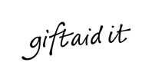
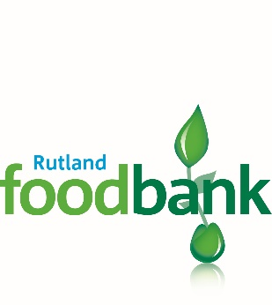

Charity No 1158460
Gift Aid Declaration
If you are a tax payer and make a donation to a charity, the charity can benefit. Please complete the declaration below.
Thank you,
Rutland Foodbank Trustees

Name of Charity: Rutland Foodbank Charity No: 1158460
Details of Donor:
Title _________ Forename(s)___________________Surname _________________
Address_____________________________________________________________
____________________________________________________________________
__________________________________________ Postcode__________________
I want the charity, Rutland Foodbank, to treat;
The enclosed donation of £__________
All donations I make today and in the future
All donations I have made in the last 4 years, and all future donations I make from the date of declaration until I notify you otherwise
as Gift Aid donations and to reclaim tax thereon.
I am a UK taxpayer and understand that if I pay less Income Tax and/or Capital Gains Tax than the amount of Gift Aid claimed on all my donations in that tax year it is my responsibility to pay the difference

Signed: _____________________________ Dated: ______________________
Please return this form to;
Michael Masters, Rutland Foodbank, 36 Melton Road, Oakham, LE15 6AY

Data Protection
Rutland Foodbank is committed to protecting your privacy and will process your personal data in accordance with current Data Protection legislation. A full data privacy statement for financial donors is available from the foodbank on request.

